8.62: The momentum of the convertible must be the south component of the total momentum, so

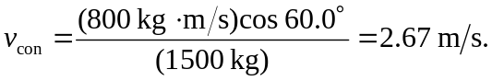
Similarly, the speed of the station wagon is

